Assignment -3

Title: MyGalleryApp

Submitted by Rohit Nadimpalli

**Github Link :**

**Design and Purpose**

I always loved zoo since my childhood and I loved exploring animals, so when we wanted to create a galley. I wanted to create a Zoo App.

For this assignment, I created a basic **Gallery App** where users can **View** **animal gallery**, **Animal pictures in full screen**, and **texts. User can edit his profile.**

**Target Audience:** Visitors.

#### **Basic Use**

The app is simple to use. Users can:

* **View Gallery View of Animals**
* **View Animals in Full screen**
* **Edit user profile**

**Things created:**

1. A Gallery screen showing a list of pictures each with a thumbnail and caption/title.
2. A Picture Viewing screen showing the full image once a picture is pressed on the gallery screen along with back button.
3. A third Profile screen to view and edit the user profile. (5 inputs, save button, used “AsyncStorage”)
4. Did error Handling
5. Created a theme and did styling
6. README.md

#### **Screenshots**

**Screenshot 1:** Gallery View of the application

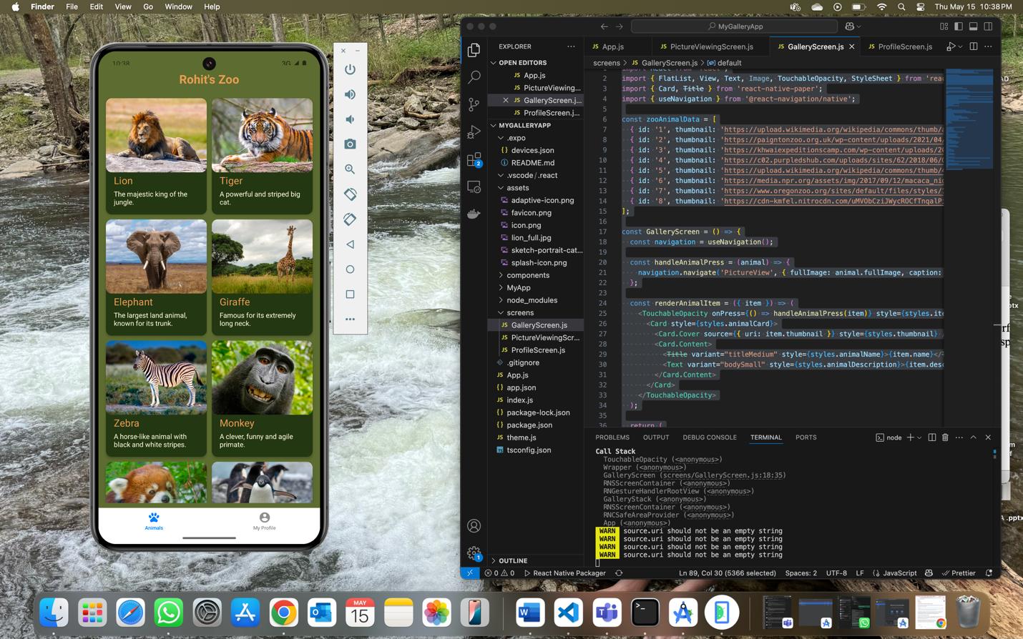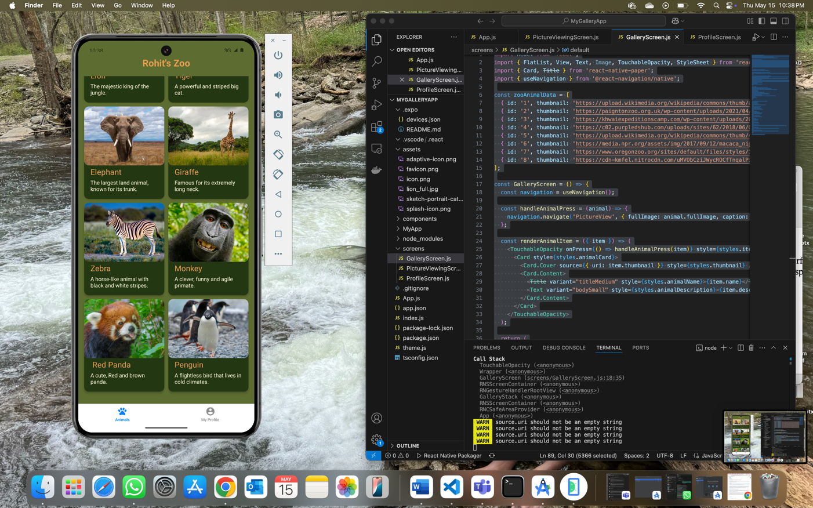

**Screenshot 2:** Picture Viewer with Caption/Title

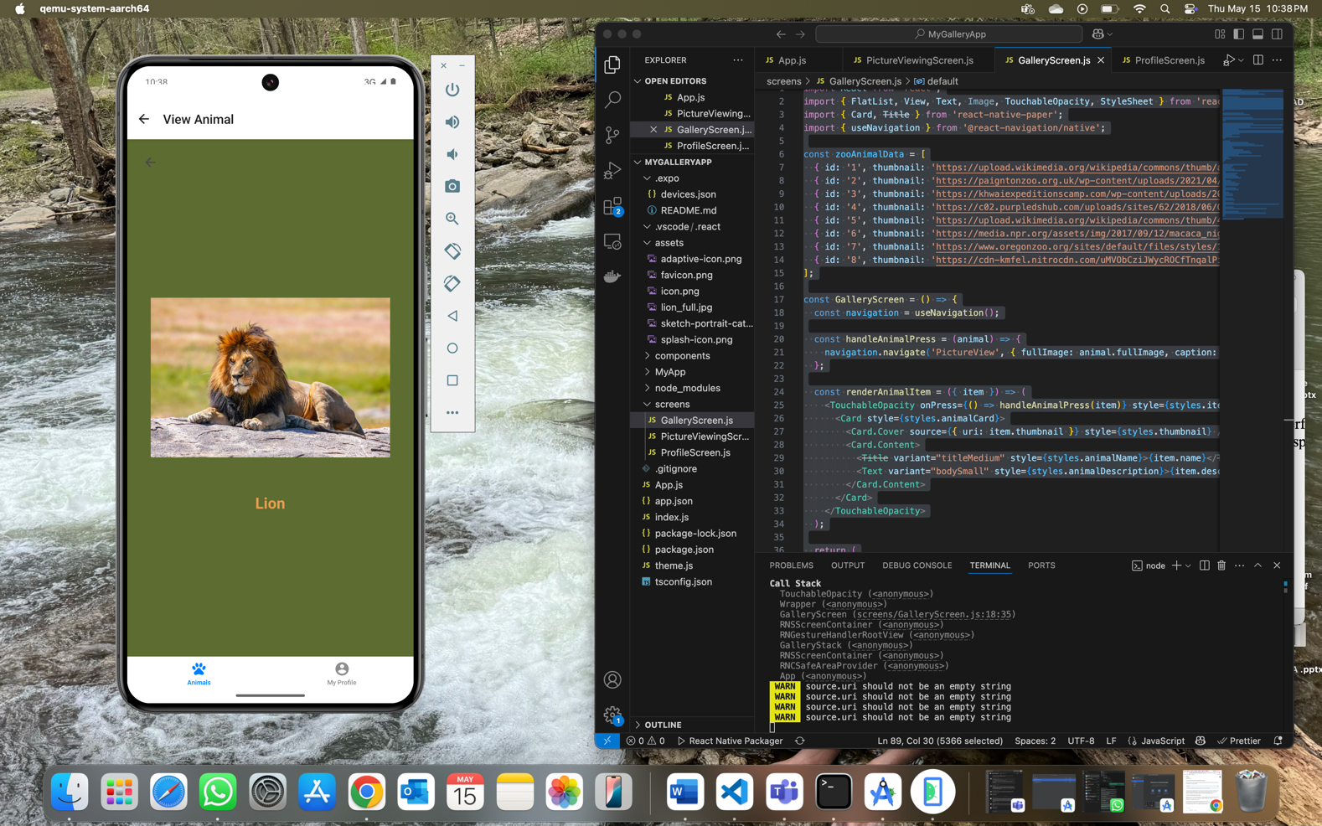

**Screenshot 3:** Profile Page

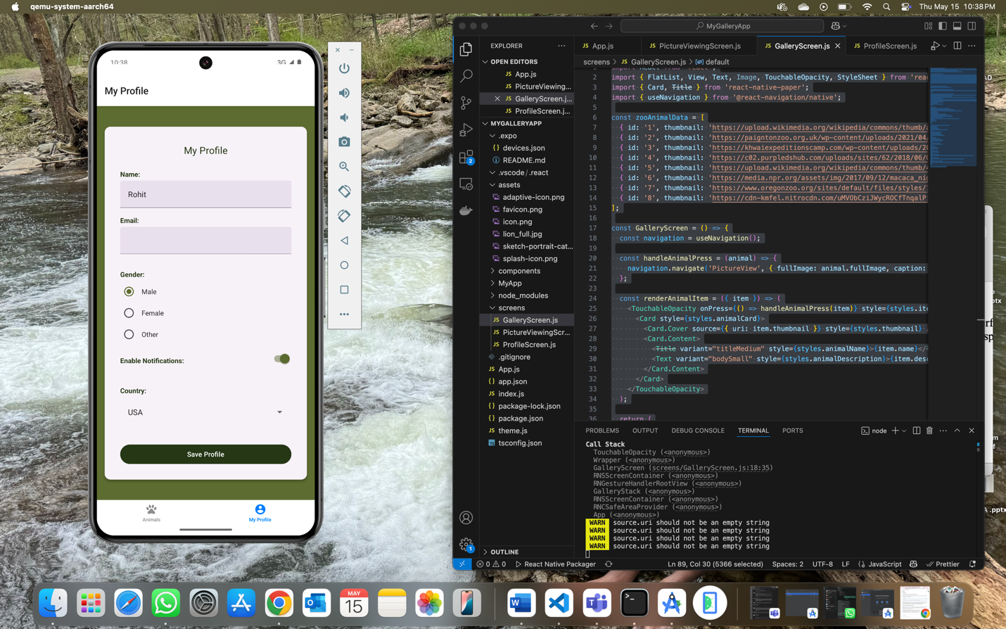

**Screenshots 4 & 5: Error Handling**  
These show how the app handles **error checking**—including cases like  **void entries**.

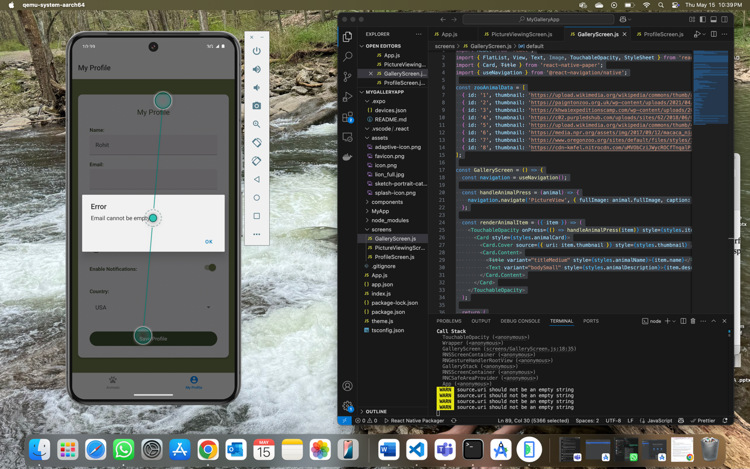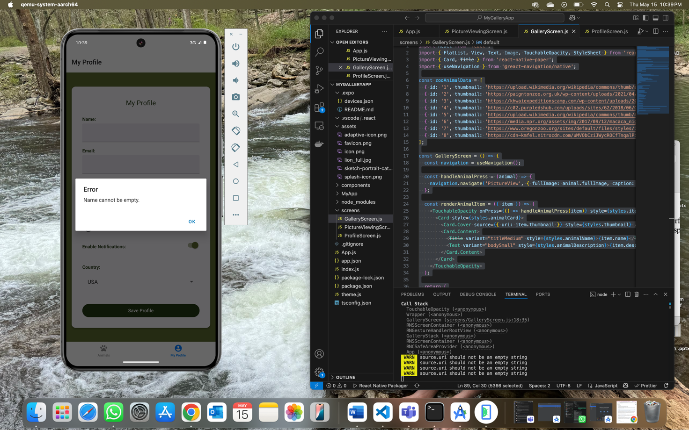

**Screenshot 6: Profile saved Successful screen**

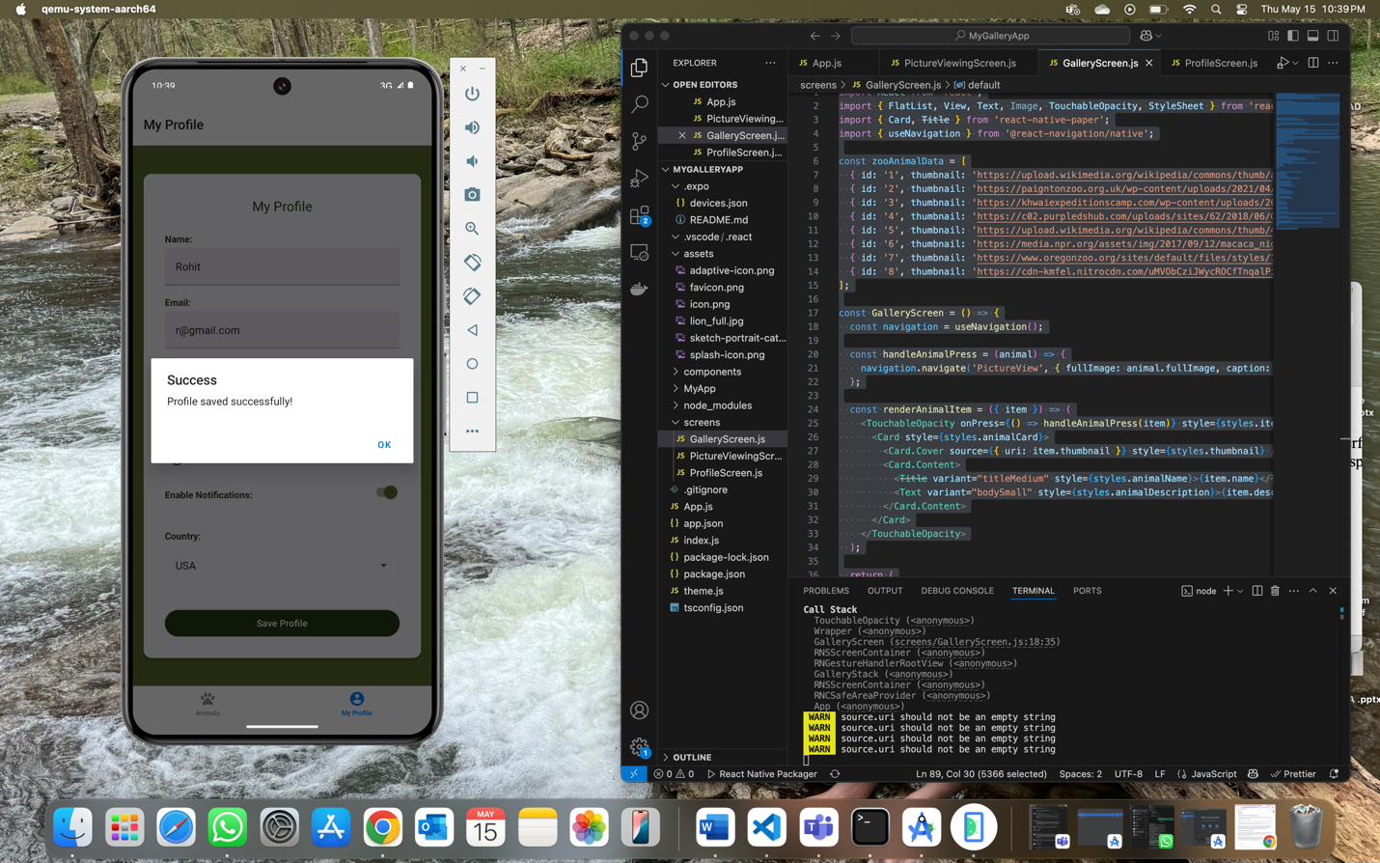

**Styling**:   
  
I have created a forest zoo theme with greens.